COM535 Cyber Security Lab

Instructions

- Visit https://www.hacksplaining.com/lessons

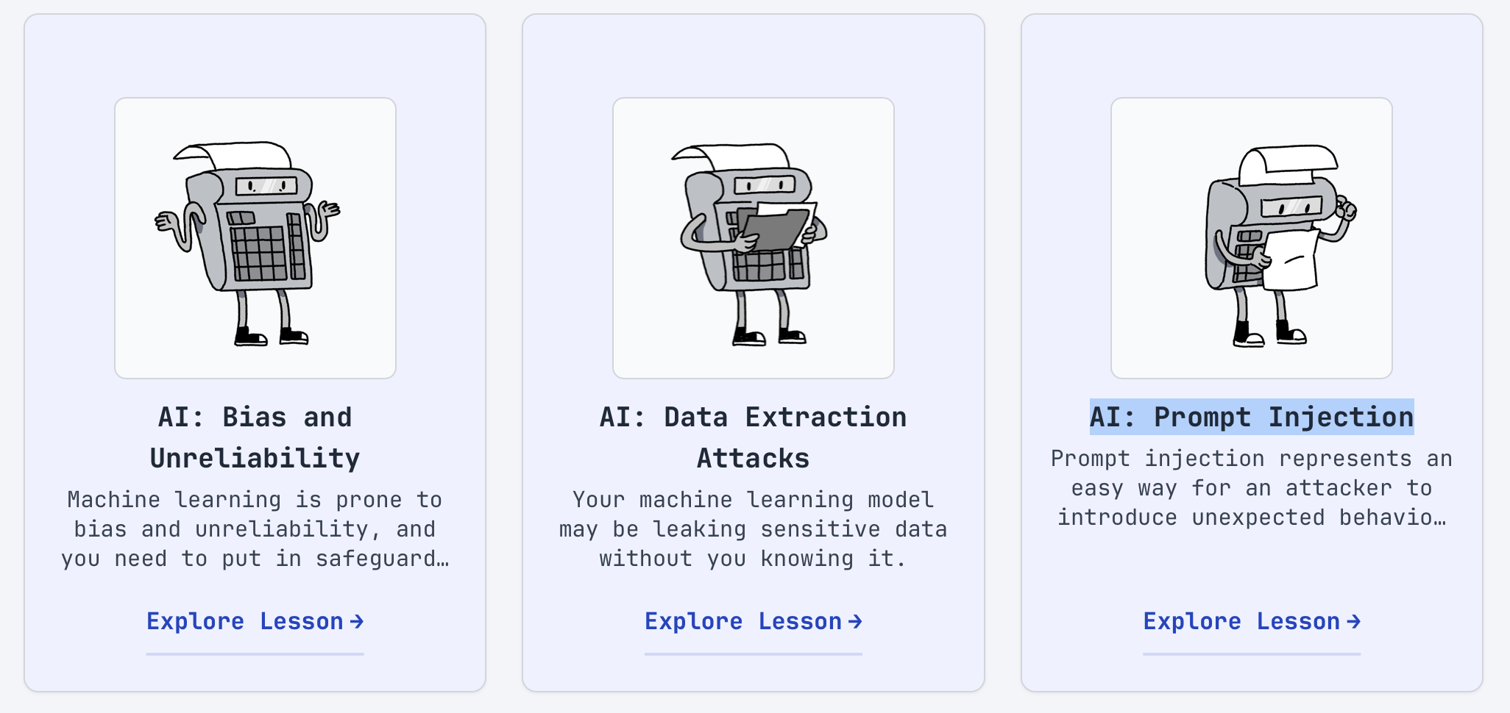

- Complete the 3 vulnerability lessons which are AI: Bias and Unreliability, AI: Data Extraction Attacks and AI: Prompt Injection.

- Visit https://tryhackme.com/

AI Models

Complete AI Models & Data
https://tryhackme.com/room/aimodelsdata

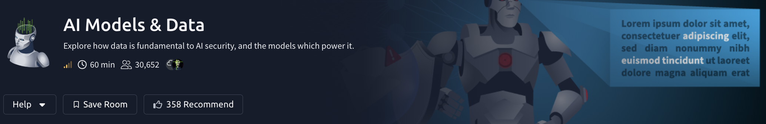

Help Video: https://www.youtube.com/watch?v=GTwtM0xALQc

AI Security Threats

- Complete AI Security Threats
https://tryhackme.com/room/aisecuritythreats

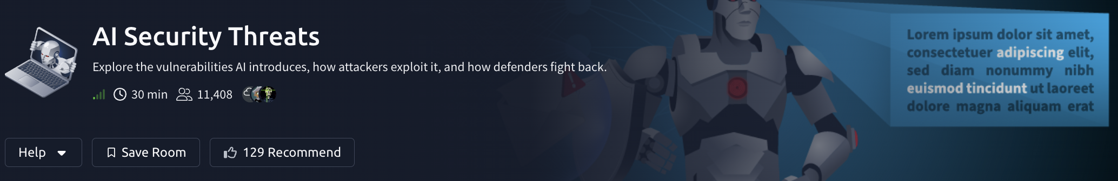

Help Video: https://www.youtube.com/watch?v=kZoXJiMYZ3A

Prompt Engineering

- Complete Prompt Engineering
https://tryhackme.com/room/promptengineeringaisec

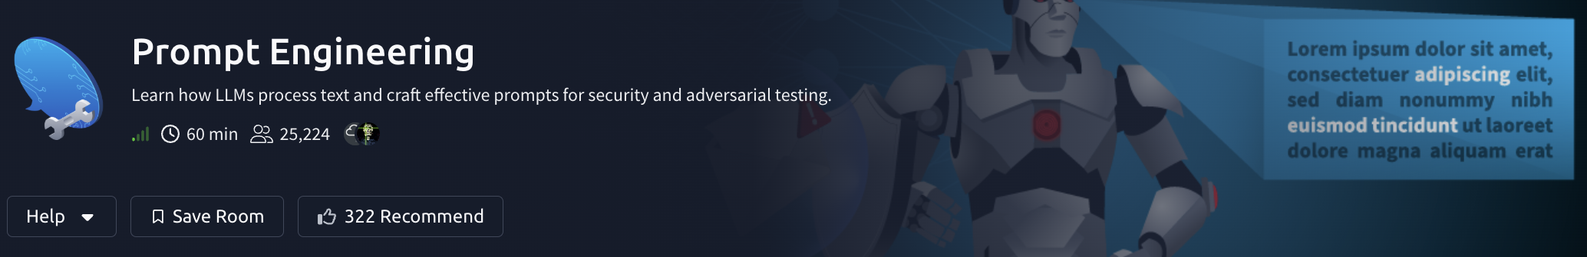

Help Video: https://www.youtube.com/watch?v=B4nFEDVqius

- Complete Prompt Injection - Sched-yule conflict
https://tryhackme.com/room/promptinjection-aoc2025-sxUMnCkvLO



Help video: https://www.youtube.com/watch?v=Ebe7HjEwZj8

